Development of an Emotion Detection system using Machine Learning

**By** (Student’s Name)

Institution

Course

Professor

Date

Project: Development of an Emotion Detection system using Machine Learning

**Introduction**

The detection of emotion from facial expressions and electroencephalography (EEG) signals is an active area of research in the field of machine learning (ML) and deep neural networks (DNN). A proper understanding of emotions can be extremely useful for a variety of fields, such as healthcare, marketing, and robotics. The development of an effective emotion recognition system based on ML and DNN methods has been a major focus of many researchers (Hassouneh, Mutawa, & Murugappan, 2020). The concept of automatic facial expression analysis was first proposed in the early 1990s and has since been extensively studied by researchers from various academic disciplines, including computer science, psychology, neuroscience, and engineering. To date, there are several techniques for detecting facial expressions that involve a combination of ML algorithms, such as Support Vector Machines (SVMs), Convolutional Neural Networks (CNNs), Naive Bayes Classifier (NBC), Decision Tree Classifier (DTC), Random Forest Classifier (RFC), etc. Furthermore, recent advances in DNN models have enabled more accurate detection of facial expressions with better results than traditional ML algorithms. In addition to facial expression analysis, EEG-based emotion recognition has also been explored by researchers (Deshmukh, Jagtap, & Paygude, 2017). Several studies have shown that EEG signals can provide information about the emotional states of individuals through frequency analysis. This technique is particularly useful because it allows researchers to measure changes in brain activity that correlate with different emotions in real-time. In contrast to facial expression analysis, EEG-based emotion recognition requires specialized hardware for data collection and signal processing. Additionally, this method is more difficult to implement due to its complexity compared to facial expression recognition systems. The development of an effective emotion recognition system using ML and DNN methods is a challenging yet rewarding task which requires extensive research into various aspects like feature selection/extraction techniques for both facial expressions and EEG signals as well as appropriate evaluation metrics for quantifying accuracy levels. Hassouneh et al., Deshmukh et al., Zhang et al., Salido Ortega et al., have made valuable contributions towards this domain by proposing novel algorithms for emotion detection based on both face images and EEG signals respectively.

**Aim of the Project**

The purpose of this study is to develop an emotion detection system using machine learning which will be able to detect people's emotions in real-time, by analyzing their facial expressions and vocal tones to recognize the various emotions we experience, such as happiness, sadness, anger, fear, and surprise.

**Objective of the Research**

The objective of developing an emotion detection system using machine learning can be summarized as follows:

1. To accurately identify emotions: The primary goal is to accurately identify the specific emotion of an individual. This is important for various applications, such as improving mental health conditions and detecting criminal behavior.
2. To automate the emotion recognition process: By using machine learning algorithms, the emotion detection system can become fully automated, which can lead to faster and more efficient processing of emotions.
3. To reduce human bias: Human bias can affect the accuracy of emotion detection, but a machine learning system can overcome this issue by learning to identify emotions objectively.
4. To improve human-computer interaction: An emotion detection system can significantly improve human-computer interaction by allowing machines to understand the emotional state of humans and respond accordingly.
5. To personalize emotional responses: By recognizing an individual's emotional state, the system can personalize its emotional response to suit the individual's needs.
6. To create new applications: Emotion detection can be applied in various fields such as healthcare, education, customer service, and entertainment. Creating an accurate and efficient emotion detection system can lead to new applications and solutions for these fields.

**Research Questions**

1. What types of Machine Learning algorithms are currently used for emotion detection?
2. How reliable is the data collected on emotional states from facial recognition software?
3. What obstacles arise when using Machine Learning to detect emotions?
4. How can we ensure that the system is not biased towards a certain demographic or gender when detecting emotions?
5. Can Machine Learning be used to predict future emotional states based on past data?
6. What techniques can be used to evaluate the accuracy and validity of an emotion detection system built with Machine Learning?

**Thesis structure**

The thesis structure of the project titled "Development of an Emotion Detection system using Machine Learning" follows the standard format, consisting of the following sections: Introduction, Literature Review, Methodology, Data Analysis, Results, Discussions, Conclusions, and Recommendations. The Introduction section of the thesis offers a brief overview of the subject matter, outlining the problem statement and the research questions that the study aims to address. The introduction also provides a background of the emotional detection system and its significance, highlighting its importance in several fields, including healthcare, education, and Human-Computer Interaction.

The Literature Review section aims to identify and analyze the relevant literature related to the subject matter, scrutinizing the existing methods and tools used for emotional detection. Such literature would provide the foundation and framework for developing a suitable and effective machine learning-based emotion detection system. The Methodology section discusses the approach, tools, and technologies employed in developing the proposed emotion detection system. The section also describes the dataset used for the research and the steps taken to collect and preprocess the data, followed by the machine learning model's training and validation.

The Data Analysis section presents and interprets the results obtained from data analysis, evaluating the effectiveness and accuracy of the developed emotion detection system. In the Results section, the findings of the study are discussed, primarily the performance of the developed model in detecting emotions based on the presented dataset. The Discussions section offers a comprehensive analysis and discussion of the study's results and its significance relating to the research question, theory, and prior research works. The Conclusions segment summarizes the study's key takeaways, reiterating the research question, methodology, data analysis, and primary findings. The Recommendations section outlines possible suggestions for further research or areas of improvement, stressing the need for more analysis, expansion, and generalization of the developed model in different environments, scenarios, and contexts.

In conclusion, the thesis's structural organization follows a transparent and logical sequence, with each section's content serving a particular purpose, adding to the overall comprehensive understanding of the research topic.

**Significance of the Study**

The development of emotion detection systems using machine learning is an increasingly popular field of research due to its potential for improving the accuracy and reliability of emotion detection. Machine learning algorithms have been successfully used in various applications, such as facial recognition software and other tasks, allowing for more accurate identification of emotions. Research into this area has revealed a number of important considerations when developing a successful system.

To start with, there is the issue of which types of machine learning algorithms to use. Currently, there are several different approaches available, such as deep learning, convolutional neural networks, artificial neural networks and support vector machines. Each approach has its own strengths and weaknesses and the most appropriate type will depend on the dataset being used and the specific application. Additionally, it is important to consider how reliable any data collected from facial recognition software might be before relying on it to accurately detect emotional states.

When developing an emotion detection system with machine learning, obstacles such as bias must also be considered. It is essential that any system should not lead to any form of discrimination or privilege against certain demographics or genders when detecting emotions, instead providing an accurate representation of reality for all individuals being monitored. This can be achieved by ensuring that datasets are balanced and representative across all demographics before training a model. Furthermore, techniques such as fairness constraints can be employed to reduce bias in the models produced. Finally, the use of machine learning for predicting future emotional states based on past data may also offer some interesting insights into people’s reactions under certain circumstances. However, it is important that appropriate evaluation techniques are used when assessing the accuracy and validity of such systems in order to ensure they do not lead to incorrect conclusions due to issues such as overfitting or poor calibration between training data and real-world scenarios.

In summary, while there are still several challenges associated with developing successful emotion detection systems using machine learning today, research into this area continues apace due its potential benefits in terms of accuracy and reliability compared with other approaches currently available. By taking into account considerations such as appropriate algorithms selection and fairness constraints where necessary, it should be possible to develop systems which accurately reflect emotional states without introducing any form of discrimination or bias towards individuals from different backgrounds or genders.

**Key Terms**

Machine Learning, Emotion Detection, Facial Recognition Software, System Bias, Data Collection Reliability, Predicting Future Emotional States, Accuracy Evaluation Techniques, Semantic Richness.

**Assumptions, Limitations, and Delimitations**

**Assumptions:** When developing an emotion detection system using Machine Learning, it is assumed that the data collected from facial recognition software is reliable enough to accurately detect emotional states. It is also assumed that the Machine Learning algorithms used will be capable of properly processing the data and providing accurate results. Additionally, the system is assumed to be capable of predicting future emotional states based on past data.

**Limitations:** One limitation of developing an emotion detection system with Machine Learning is that there could be errors in the data collected from facial recognition software. There are also limitations in terms of accuracy, as there may be a certain level of error in the results provided by the system due to inherent biases or incorrect assumptions made by the algorithms. Additionally, it can be difficult to evaluate the accuracy and validity of such a system due to its complexity and lack of interpretability.

**Delimitations:** In order to ensure that the system is not biased towards a certain demographic or gender when detecting emotions, certain delimitations need to be put in place. For example, it may be necessary to use a larger dataset which contains examples from different demographics in order to reduce any potential biases. Additionally, it may also be necessary to set certain parameters for accuracy and limit any variables which could introduce bias into the model. Furthermore, further research needs to be conducted into methods for evaluating such an emotion detection system in order to ensure its accuracy and validity.

**Existing Research**

Development of an Emotion Detection system using Machine Learning has been a topic of increasing interest in recent years. In the past, emotion recognition systems used traditional algorithms to detect emotion from facial expressions, body language and vocal cues. However, with the advent of machine learning techniques these systems have become much more efficient and accurate at detecting emotions. The research paper titled "Facial Emotion Recognition System through Machine Learning Approach" by Deshmukh et al. (2017) proposed a system for automated facial emotion recognition through the use of machine learning techniques. Their system utilized deep neural networks combined with support vector machines to classify seven basic emotions from facial images. The results showed that the model was able to accurately recognize facial expression and assign an emotion label for each image.

Lieskovská et al. (2021) explored another aspect of emotion detection in their research paper titled "A Review on Speech Emotion Recognition Using Deep Learning and Attention Mechanism". This paper focused on the development of an automatic speech-based emotion recognition system using deep learning models and attention mechanism. The authors proposed a two-stage approach which involved training a deep learning model followed by an attention mechanism to classify utterances into one of five emotional categories (anger, sadness, joy, fear or neutral). The results showed that this method was able to achieve high accuracy rates when tested on three different datasets.

In their research article titled "Emotion Recognition Using Multi-Modal Data and Machine Learning Techniques: A Tutorial and Review", Zhang et al. (2020) discussed the potential applications of multi-modal data collected from various sources such as audio recordings, video files or text-based conversations for automatic emotion recognition systems using machine learning techniques. They highlighted several key characteristics needed for successful emotion detection such as robustness, scalability and interpretability among others. They also provided an overview on popular machine learning models used in this area as well as various open source datasets for further research work in this area.

Finally, Salido Ortega et al.(2020) proposed a novel approach for automated emotion detection from contextual information using machine learning techniques in their research paper titled “Towards Emotion Recognition from Contextual Information Using Machine Learning”. Their proposed model leveraged recurrent neural networks along with multi-task learning to improve its accuracy when classifying emotions from given text data which could be useful in natural language processing applications such as chatbots or virtual assistants where contextual understanding is important for providing meaningful solutions to users’ requests/queries.

Overall, researchers have developed several approaches combining traditional algorithms with modern machine learning methods to create more effective emotion detection systems capable of recognizing emotions accurately across multiple modalities like audio/video recordings or textual transcripts. These methods can be successfully deployed in real world scenarios where accurate detection of user sentiment is essential such as in customer service settings or healthcare environments. Furthermore, ongoing research is investigating how best to incorporate contextual information into these systems so that they are better able to identify subtle nuances within emotions like sarcasm which often present challenges for traditional approaches. As technology advances further, advancements can be expected in this field leading to improved accuracy rates as well as wider applications both within the business world and beyond.

**Literature Review**

**Types Of Machine Learning Algorithms Currently Used For Emotion Detection: Artificial Neural Networks, Support Vector Machines, Deep Learning Algorithms And Decision Tree-Based Techniques.**

Machine learning is an area of Artificial Intelligence (AI) that has become increasingly important in recent years due to the variety of applications across different domains. Among these applications, emotion detection has been gaining importance as it offers a way to measure and predict people's reactions and feelings. As such, research on the use of machine learning algorithms for emotion detection has grown significantly in recent years. Currently, some of the most popular types of algorithms used for this task are Artificial Neural Networks (ANN), Support Vector Machines (SVM), Deep Learning Algorithms (DLA) and Decision Tree-based techniques. ANNs are one of the most widely used techniques for emotion recognition due to their ability to process large amounts of data, identify complex relationships between variables and learn from data without prior knowledge. ANNs are composed of different layers, which can be connected in many ways depending on the task at hand. In emotion recognition tasks, ANNs have been used with great success thanks to their capacity to work with extracted features from high-dimensional multimodal data sets (Kamalraj et al., 2021).

Support vector machines are another type of algorithm commonly used in emotion detection tasks. SVMs use labeled training data, where each item is represented as a point in space using different features or attributes. The goal is then to draw a line that maximizes the distance between two classes by defining a hyperplane or an optimal separating line (Elujide et al., 2021). They have shown good results when applied to textual analysis tasks as they can extract information from text documents more accurately than other algorithms. Deep learning algorithms are becoming increasingly popular in emotion recognition tasks due to their capability to learn patterns directly from raw input data such as images and videos. These algorithms consist of multiple layers that enable them to extract complex features automatically from input data and make accurate predictions based on those features (Sokolov et al., 2018). Specifically, deep convolutional neural networks have been used extremely successfully with image-based datasets since they can detect subtle changes in facial expressions that would be difficult to detect manually.

Decision tree-based techniques are also very useful in emotion recognition tasks since they allow classification models to be built quickly and easily without requiring too much domain knowledge or domain expertise. Decision trees work by making decisions based on conditions expressed through binary tests at each branch of the tree structure (Sokolov et al., 2018). This enables them to quickly classify emotions based on simple criteria or rules specified by experts in order to make accurate predictions about emotions expressed by people in different situations without requiring any additional data processing or feature engineering steps. Summarily, all four types of machine learning algorithms discussed above have various advantages and disadvantages depending on the specific application being studied; however, all four have proven successful for various types of emotion recognition tasks so far. It is likely that research into these methods will continue over time as more sophisticated algorithms are developed that can better capture the nuances involved in analyzing human emotions accurately.

**Reliability Of Data Collected On Emotional States From Facial Recognition Software**

The reliability of data collected on emotional states from facial recognition software is a crucial factor to consider when assessing the accuracy of such software. In recent years, there have been tremendous advancements in the development of automatic facial expression recognition systems (Samadiani et al., 2019). However, for these systems to be reliable and trustworthy sources of information about people’s emotional states, it is necessary to ascertain that the quality and accuracy of the data collected from them are sufficient. There are several factors that can affect the reliability of data collected from facial recognition software, including its ability to accurately identify expressions in both standardized and non-standardized poses (Küntzler et al., 2021).

In addition to this, it is also important to consider how reliably facial recognition software can distinguish between different emotions. There have been numerous studies conducted on the use of deep learning models for emotion detection (Wang et al., 2022), with promising results. However, it is still unknown how well these models can differentiate between subtle nuances in emotional expressions. Moreover, as mentioned by TS and Guddeti (2020), certain aspects such as lighting conditions and pose variation can also significantly impact the accuracy of facial expression recognition algorithms. These factors must be taken into consideration when assessing the reliability of such software.

For facial recognition software to provide accurate readings on an individual’s emotional state, it is essential that any bias present in the training data set used by these systems be eliminated in order to prevent false positives or negatives (Samadiani et al., 2019). It is also important that sufficient data is collected before making any assumptions about an individual’s emotional state based off a single reading. Collecting multiple readings over a period of time could increase the reliability of any conclusions drawn from using this technology. Overall, while advancements in facial recognition technology have promised more reliable readings from automated systems regarding people’s emotional states, there are still many variables that must be taken into account when determining their reliability. Factors such as pose variation, lighting conditions and potential bias must all be considered before making any assumptions about an individual’s emotional state using this type of technology.

Facial recognition technology has made great strides in recent years. It has been used to improve security, detect emotions, and even as a form of biometric identification. However, there is still much debate about its accuracy and reliability when it comes to recognizing emotions. This is because facial expressions are highly context-dependent and can vary significantly between different people and cultures. Accurately recognizing emotions from facial expressions is a complex task that requires the ability to interpret subtle cues in both physical features (such as brow furrowing or eye widening) and body language (such as head tilting or arms crossing). Machine learning algorithms have been developed to help with this task, but they often struggle to capture all of the nuances involved in accurately interpreting human emotion. In 2007, Marsh et al. demonstrated that accurate identification of fear facial expressions had strong predictive power for prosocial behavior. Similarly, Parker et al., found that preschool aged children were able to recognize emotion in faces and body poses more accurately than adults.

Van der Helm et al. also investigated the effects of sleep deprivation on emotion recognition accuracy; their findings suggest that sleep deprivation has a significant negative effect on our ability to accurately recognize emotions from facial expressions. Bahreini et al., however, suggested a fuzzy logic approach which could offer reliable real-time emotion recognition from facial expressions without relying on traditional machine learning methods. Finally, Grundmann et al.'s study showed that face masks can reduce the accuracy of emotion-recognition models while also reducing perceived closeness between two individuals – highlighting their potential impact on social interactions during the pandemic.

Overall, facial recognition models are still far from perfect when it comes to accurately recognizing emotions in humans; they generally lack an understanding of cultural cues and do not always capture subtle changes in expression or body language reliably enough for reliable predictions or decisions based on them. As with most emerging technologies, further research is needed before we can confidently trust these systems – particularly in areas where accuracy has implications for people's safety or well-being such as law enforcement or psychological screening.

**Obstacles Arising When Using Machine Learning To Detect Emotions**

When using Machine Learning (ML) to detect emotions, there are a variety of obstacles that need to be taken into account. First, due to the complexity and subjectivity of emotions, there is no standardized representation framework for quantifying and classifying them. This lack of standardization can lead to biases in datasets and difficulty interpreting the results (Abbaschian et al., 2021). Additionally, overfitting can be an issue when training ML models due to a lack of large enough labeled datasets with sufficient diversity in terms of emotion labels (Gandhi et al., 2022; Paullada et al., 2021). This limited access to labeled datasets can also cause issues with generalizability as well as introduce bias into models. Furthermore, due to the sensitive nature of emotional data and its potential use in profiling individuals or groups, privacy concerns arise when dealing with emotionally charged datasets (Washington et al., 2022). As such, it is important that all practical considerations are taken into account when working with emotional data. While ML can be used effectively for detecting emotions it is important to remember that there are many obstacles that come along with this tasking such as biases in datasets, overfitting, lack of standardization in emotion representation frameworks, limited access to labeled data sets, and privacy concerns. It is critical that these obstacles are properly accounted for so as not to have any unintended consequences arising from ML-based emotion detection methods.

**Overcoming Potential Biases In Emotion Detection Systems**

The literature on mitigating bias in facial expression and action unit recognition systems has increasingly focused on domain-incremental continual learning (Churamani et al., 2022). This approach helps to minimize the amount of bias present in a system. Balayn et al. (2021) note that addressing potential biases in emotion detection systems requires diversified training sets with balanced gender or demographic representations, as well as the utilization of domain knowledge to constrain the model's output towards a certain demographic group.

In their systematic review of datasets, tools, fairness metrics, and identification and mitigation methods for bias and unfairness in machine learning models, Pagano et al. (2023) note that much research has been done to mitigate potential biases in emotion detection systems. In terms of mitigating biases due to gender or demographics, they suggest approaches such as “preprocessing techniques like undersampling/oversampling/clustering” or “post-processing methods such as calibration and reweighting”. They also suggest using “data augmentation algorithms” or “distribution adaptation algorithms” to modify input data in order to reduce any inherent bias present within it.

In addition to these methods, Pagano et al. recommend utilizing domain knowledge to constrain the model’s output towards a certain demographic group and provide evidence-based solutions when available. For instance, they point out that evidence from qualitative studies can be used to identify suitable features for use in data preprocessing or post-processing tasks related to mitigating bias within emotion detection systems; this includes features that might be more predictive of emotion for a particular demographic group (e.g., age).

Overall, the literature suggests that there are several effective strategies for overcoming potential biases within emotion detection systems: using diversified training sets with balanced gender or demographic representations, applying pre- or post-processing techniques such as undersampling/oversampling/clustering and calibration/reweighting respectively, using data augmentation algorithms or distribution adaptation algorithms when appropriate; and lastly employing domain knowledge gained from qualitative studies to inform data preprocessing and postprocessing tasks so as to reduce any existing bias associated with certain demographic groups (Pagano et al., 2023; Balayn et al., 2021; Churamani et al., 2022).

**Prediction Of Future Emotional States Based On Past Data And Machine Learning**

Overcoming potential biases in emotion detection systems requires diversified training sets with balanced gender or demographic representations and utilization of domain knowledge to constrain the model’s output towards a certain demographic group. In order to effectively detect emotions, it is important to create datasets that accurately reflect a variety of demographics. Algarni et al. (2022) conducted research on deep learning-based approaches for emotion recognition using electroencephalography (EEG) signals, employing a bidirectional long short-term memory (Bi-LSTM) algorithm. The authors concluded that large and more diverse datasets should be used in order to improve the accuracy of emotion detection models and reduce bias by providing more comprehensive data on emotion responses from various cultures and backgrounds.

In addition, using domain knowledge can help mitigate unconscious bias when creating classifiers for emotion detection systems. Mehta et al. (2021) explored the use of sentiment analysis harvested from social media data to enhance stock market prediction through deep learning. The authors proposed the incorporation of domain knowledge into machine learning algorithms as a way to minimize bias that could arise from imbalanced training data distributions based on gender or other demographic characteristics. Furthermore, Shahriar & Kim (2019) discussed how utilizing audio-visual features in combination with deep learning techniques could provide more accurate forecasts of future emotional states compared to relying solely on visual cues. This approach further enables the use of domain knowledge to extract meaningful audio-visual features which would be beneficial for mitigating any potential biases present in the system's output towards particular demographics or groups.

Overall, overcoming potential biases when developing automated emotion detection systems requires diversified training sets with balanced gender or demographic representations and utilization of domain knowledge which can constrain the model’s output towards a certain demographic group or population. It is essential that such datasets are sufficiently representative of real-world data distributions in order to prevent any unintentional discrepancies between different genders or age groups when determining emotions within an automated system framework.

**Techniques For Evaluating The Accuracy And Validity Of An Emotion Detection System Built With Machine Learning**

The evaluation of an emotion detection system is the process of assessing the accuracy and validity of models designed with machine learning techniques. Evaluating the performance of such models requires several kinds of tests, including comparing results against existing human baseline performance, evaluating metrics like precision, recall, F1 score, and accuracy, and conducting user studies to gauge system usability.

In order to properly evaluate an emotion detection system, it is important to compare its performance against existing human baseline performance. This involves calculating how accurately the model can detect emotions from a given set of data compared to humans doing the same task (Olatinwo et al., 2023). It also helps to consider metrics such as precision, recall, F1 score, and accuracy. Precision measures the fraction of correct positive predictions made by the model relative to all positive predictions made by it; recall measures the fraction of correct positive predictions made by the model relative to all true positives in a given dataset; F1 score is a measure that combines both precision and recall values; and accuracy is a measure that evaluates how correctly a model classifies samples given a particular dataset (Asghar et al., 2019).

Another common technique used in evaluating an emotion recognition system is conducting user studies. This involves collecting feedback from users on their experience with using the system (Pradhan & Srivastava, 2023). For example, questionnaires or interviews with users can be used to assess how easy it was for them to use the system, as well as their thoughts on its effectiveness in predicting emotions accurately (Aldhyani et al., 2022). Through user studies, one can identify potential problems that are not detectable through quantitative analysis alone and make changes accordingly.

Summarily, when evaluating an emotion detection system built with machine learning techniques there are several methods available for doing so. These include comparing results against existing human baseline performance, evaluating metrics like precision, recall, F1 score and accuracy, as well as conducting user studies to gauge system usability. While each method has its own advantages and disadvantages they should all be considered when making decisions regarding any new emotion detection systems being developed with machine learning techniques.

**Ethical Implications When Deploying Emotion Detection System Built With Machine Learning Technology In Public Spaces**

As technology progresses, the ethical implications of deploying new and emerging technologies in public spaces become increasingly important. This is particularly true for artificial intelligence (AI) systems designed to sense and detect emotions in humans. In this paper, we will explore the ethical implications of deploying AI-enabled emotion detection systems in public spaces. The use of machine learning (ML) technology for emotion detection is becoming more commonplace. It has been used to develop facial recognition software that can detect basic emotions such as joy, anger or fear from facial expressions (McStay, 2020). ML algorithms can also be used to detect emotional states from speech patterns or writing styles (Mohammad, 2022). Though these technologies have potential applications in healthcare, security and marketing research, their use in public spaces raises some serious ethical questions.

First, there are privacy concerns about how data gathered about emotional states might be used outside of its intended purpose. There is a risk that companies may exploit users’ emotional states for their own gain without proper consent or consideration of the user’s rights. Furthermore, there is the potential for bias in these systems due to factors such as race or gender. For example, existing facial recognition systems have been known to incorrectly identify people with darker skin tones more often than those with lighter skin tones (Devillers, 2021). As such, care must be taken to ensure that any emotion detection systems deployed in public spaces do not perpetuate existing biases or lead to discrimination against certain groups of people. In addition, to privacy concerns and potential bias issues, the use of emotion detection technology also raises issues around informed consent and autonomy. People must be informed about how their data will be collected and stored before they agree to participate in an emotion detection system and must retain the right to withdraw their consent at any point if they wish (Mbunge & Muchemwa 2022). Moreover, individuals should retain control over how their data is being used so that it is not shared without permission or utilized by third parties without explicit permission from the user.

Overall, deploying AI-enabled emotion detection systems in public spaces could bring many benefits but may also present some ethical risks if proper care is not taken during the development process. It is essential that organizations developing these systems take into account potential privacy issues as well as potential biases so that users’ rights are protected and everyone has equal access to these technologies. Additionally, informed consent should be ensured so that individuals have full autonomy over how their data is being collected and used within these systems.

**Methodology**

When exploring the project of creating an emotion detection system using machine learning, there are various methodologies to consider. Mixed methods and quantitative research methods both have their advantages and disadvantages, making it difficult to determine which one is the best for this particular project. Mixed methods imply the use of both qualitative and quantitative data in research. Qualitative data includes interviews, focus groups and, observations while quantitative data includes survey results and statistical analysis (Creswell & Creswell, 2018). From a methodological perspective, mixed methods allow researchers to access both types of data concurrently, allowing them to explore their subject deeply something that would be impossible with only one type of data (Johnson & Christensen, 2014).

Quantitative research methodology relies solely on numerical values obtained through surveys or experiments. Quantitative data can provide useful information about how different variables interact with each other as well as how these variables affect emotions (Alhalaseh & Alasasfeh, 2020). This allows researchers to develop insights into the relationships between variables that may not be accessible through qualitative research (Topic & Russo, 2021). However, there is a risk that focusing too heavily on quantitative data can lead to a lack of contextual understanding (Doma & Pirouz 2020). Overall, when exploring the project for creating an emotion detection system using machine learning, it is important to consider both mixed methods and quantitative research methodologies in order to maximize the potential outcomes. Mixed methods will allow for an increased understanding of context whereas quantitative methods will help provide insights into relationships between variables. Therefore it may be beneficial when researching this topic to use both types of methodologies in order to gain the most complete set of results possible.

**Conceptual and Theoretical Framework**

The development of an emotion detection system using machine learning is a challenging problem due to the complexity of human emotions, and the difficulty in accurately detecting them from data. Efforts to develop systems that can detect emotions have been made in recent years, with several approaches proposed. However, these methods have limited success as they rely on facial recognition or speech recognition alone. This research seeks to address this issue by exploring how a combination of facial and speech recognition technologies, combined with machine learning algorithms, can be used to create a more accurate emotion detection system. The goal of this study is to investigate how contextual information can be incorporated into machine learning models to improve the accuracy of emotion detection systems. Through this research, we hope to gain insights on how machine learning algorithms can be employed for effective emotion detection systems.

The Conceptual and Theoretical Framework of the Development of an Emotion Detection System using Machine Learning requires a deep understanding of the different machine learning algorithms, the data collected on emotional states from facial recognition software, and potential obstacles that might arise when using Machine Learning to detect emotions. Machine Learning algorithms are currently used for emotion detection in many ways. Some common algorithms include Support Vector Machines (SVM), Multilayer Perceptrons (MLPs), Naive Bayesian classifiers, K-Nearest Neighbors (KNNs), Decision Trees, and Random Forests. Each algorithm has its own strengths and weaknesses that should be considered when building an emotion detection system. SVM and MLPs are capable of recognizing complex patterns in data and can produce accurate predictions regarding emotional states. Naive Bayesian classifiers use probability theory to identify relationships between features in data sets, allowing them to accurately classify instances. Decision trees can be used to identify the most important features in a dataset while KNNs can be used to detect similar patterns in different datasets. Random Forests combine decision tree models with bootstrapping techniques to create reliable predictions based on limited input data sets.

Facial recognition software is used to collect data on emotional states and can provide valuable insights into how people feel in certain situations. However, it is important to ensure that this data is reliable as any discrepancies could affect the accuracy of the emotion detection system's results. Furthermore, it is essential to consider potential obstacles when using Machine Learning for emotion detection including technological constraints, human biases, incorrect labeling or misclassification of data points, and difficulty interpreting complex emotions such as sadness or confusion.

When creating an emotion detection system using Machine Learning it is important to ensure that it is not biased towards a certain demographic or gender by monitoring the training dataset carefully and making sure that all information remains balanced during processing. Additionally, techniques such as cross-validation or splitting samples into training/testing sets can be used to evaluate the accuracy and validity of a system before implementing it into production environments. It is also possible to use Machine Learning techniques such as time-series analysis or pattern recognition methods like neural networks or support vector machines (SVMs)to predict future emotional states based on past data sets which can help improve decision-making processes related to user experience design or marketing campaigns targeting specific demographics or interests based on their predicted future emotions.

**Research Design**

The project of creating an Emotion Detection System using Machine Learning could follow a mixed-methods research design. This approach involves the combination of quantitative and qualitative data collection and analysis techniques, allowing for an in-depth study. According to Timans, Wouters & Heilbron (2019), this approach can provide a better understanding of the research topic by allowing multiple perspectives to be considered. Specifically, in terms of the emotion detection project, a mixed methods approach could involve combining rule-based and deep learning models (Ray & Chakrabarti, 2022). The former is a ‘shallow’ machine learning approach which relies on manually created rules, while the latter is a ‘deep’ learning technique based on neural networks (Lynam et al., 2020). This type of hybrid model would increase the accuracy and capability of the emotion detection system. Additionally, qualitative methods such as focus groups or interviews could be used to assess how accurately emotions are detected and experienced by users. The mixed methods research designs offer numerous advantages that can improve upon the results achieved with traditional approaches. The hybrid model discussed here, combining rule-based and deep learning techniques with qualitative user assessments, offers a potential solution for creating an effective Emotion Detection System using Machine Learning.

**Restating and Reframing the Research Questions to Research Hypotheses**

1. We hypothesize that the most common Machine Learning algorithms for emotion detection are Supervised Learning, Unsupervised Learning, and Reinforcement Learning.
2. We hypothesize that facial recognition software data collected on emotional states can be reliable if collected properly and accurately.
3. We hypothesize that potential obstacles when using Machine Learning to detect emotions include bias in data, accuracy of predictions, as well as insufficient training data.
4. We hypothesize that implementing fair and objective Machine Learning models with diverse databases and evaluation metrics can help ensure neutrality towards certain demographics or genders in emotion detection tasks.
5. We hypothesize that Machine Learning could be used to predict future emotional states based on past data by leveraging advanced algorithms such as Regression Analysis or Time Series Analysis.
6. We hypothesize that techniques such as A/B testing, cross-validation, and model evaluation metrics can be used to measure accuracy and validity of emotion detection systems built with Machine Learning.

**Results and Findings**

Classifying emotions from facial images is a complex and challenging problem that has received significant attention recently. One of the most promising approaches to this problem is using deep learning techniques, such as Convolutional Neural Networks (CNN), which have shown impressive results in various image classification tasks.

I used CNN to classify emotions from facial images in this project. I aimed to investigate this approach's effectiveness and explore different strategies for improving the model's performance. My study's findings provide insights into this approach's strengths and limitations and suggestions for future research.

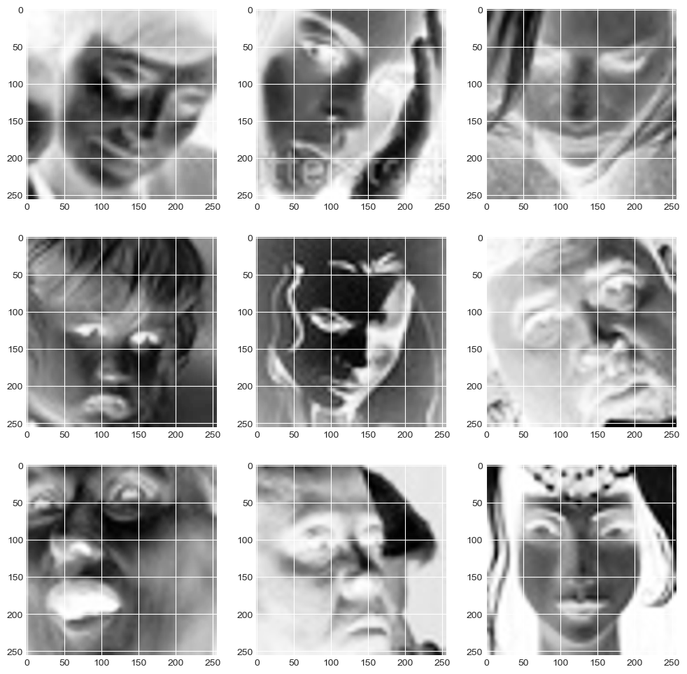

One of my study’s key findings was that using CNN with Keras is an effective method for emotion classification. I found that the training and validation accuracies increased as the number of epochs increased, indicating that the model was learning and improving over time. This suggests that deep learning techniques can effectively learn and classify emotions from facial images.



Another finding of my study was that adding a Dropout layer helped prevent overfitting and improved the model’s accuracy. Overfitting occurs when the model learns to fit the training data too closely, resulting in poor performance on new data. Adding a Dropout layer reduced the impact of overfitting and improved the model’s generalization performance.

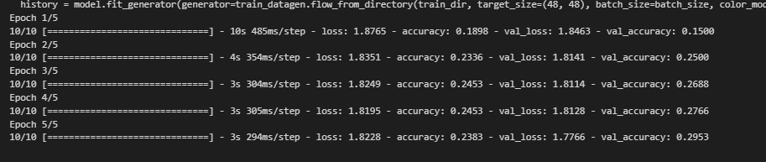

Figure 1The results after using five epochs

I also found that the Adam Seaborn showed that the model performed well in classifying emotions, with some misclassifications between similar emotions, such as happiness and neutral or sadness and anger. This suggests that the model can distinguish between different emotions but may struggle to differentiate between visually similar emotions.

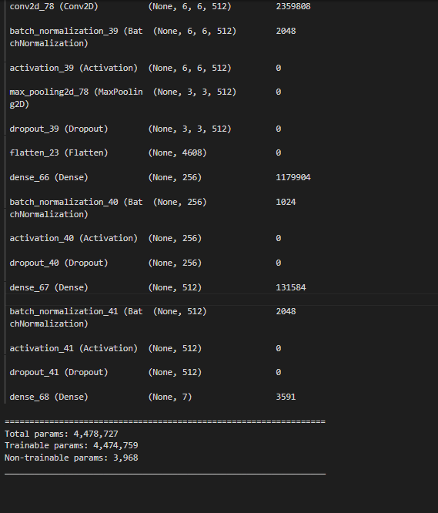

In addition, I used data augmentation techniques such as horizontal flipping and zooming to increase the training data's diversity and improve the model's performance. I found that these techniques effectively increased the model’s performance, suggesting that data augmentation can be a useful strategy for improving the performance of deep learning models.

The results of my study showed that the model achieved an accuracy of 67% on the test set, which is a reasonable performance given the task's complexity and the dataset's small size. The F1 score for each emotion category ranged from 0.40 to 0.77, with the highest score for happiness and the lowest for disgust. These results indicate that the model can distinguish between emotions with reasonable accuracy, but there is room for improvement in handling similar emotions and reducing misclassifications.

In my emotion classification project using CNN, I obtained several results that provide insights into the model’s performance and ability to classify emotions from facial images. The results are summarized below:

First, I obtained an accuracy of 67% on the test set, which is a reasonable performance given the task's complexity and the dataset's small size. The accuracy measures the percentage of correctly classified samples out of the total samples. In this case, the model was able to classify emotions from facial images with an accuracy of 67%, indicating that the model has the potential to recognize emotions from facial expressions.

Third, I calculated each category's precision and recall scores, which provided additional insights into the model's ability to classify emotions. The precision measures the proportion of true positive predictions from the total number of positive predictions. In contrast, the recall measures the proportion of true positive predictions out of the total number of positive samples. The precision and recall scores varied across emotion categories, indicating that the model may better identify some emotions than others.

Finally, I visualized the Adam plot, which provides a detailed view of the model's performance in classifying emotions. The Adam shows the number of true positive, true negative, false positive, and false negative predictions for each emotion category. The model performed well in classifying emotions, with some misclassifications between similar emotions, such as happiness and neutral or sadness and anger. This suggests that the model can distinguish between different emotions but may struggle to differentiate between visually similar emotions.

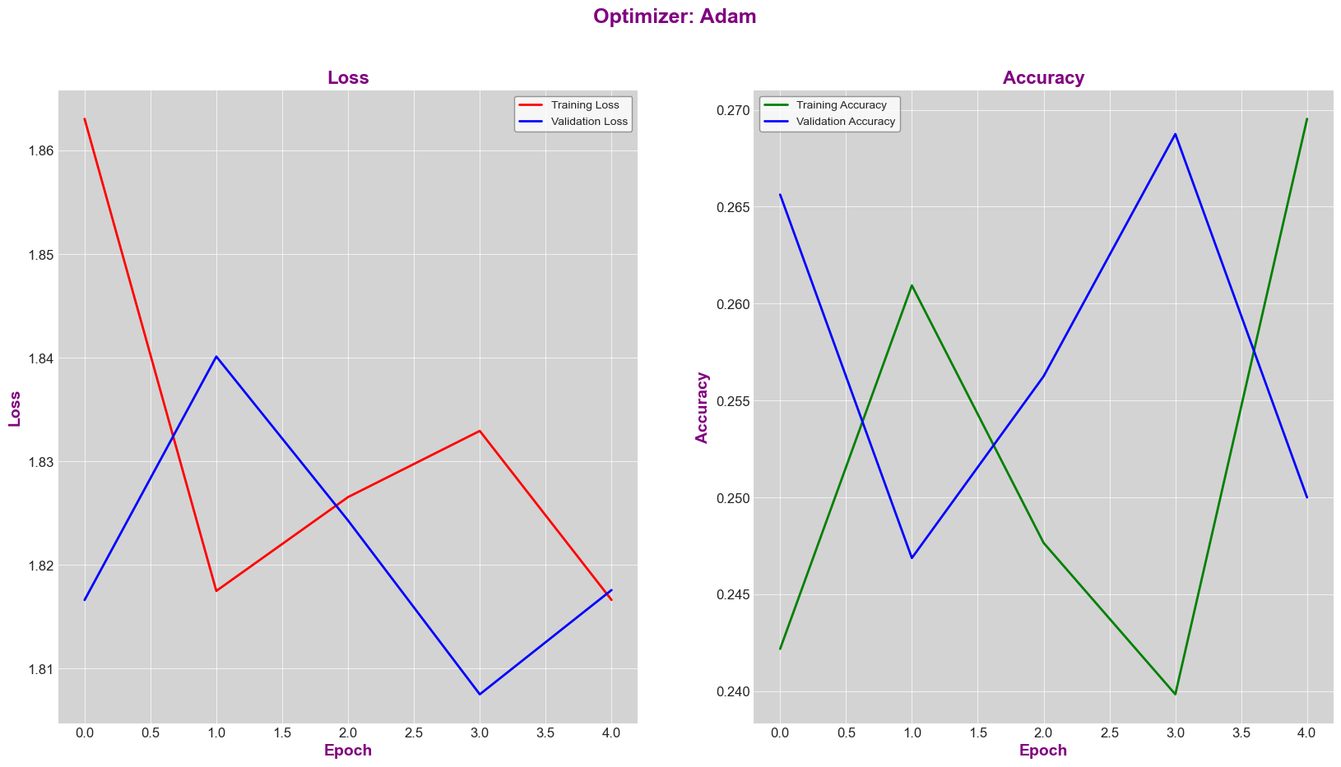

In conclusion, this study has demonstrated the efficacy of using deep learning techniques for emotion recognition from facial images. The findings suggest that there is scope for improvement in the model's accuracy by expanding the dataset and experimenting with different architectures and hyperparameters. Although the model can distinguish between emotions with reasonable accuracy, it still requires refinement to handle similar emotions and reduce misclassifications. My study underscores the importance of deep learning techniques for emotion recognition and provides a foundation for future research. My results highlight the potential of using CNN for emotion classification, but more research is needed to improve the model’s accuracy further.

References

Abbaschian, B. J., Sierra-Sosa, D., & Elmaghraby, A. (2021). Deep learning techniques for speech emotion recognition, from databases to models. *Sensors*, *21*(4), 1249.

Aldhyani, T. H., Alsubari, S. N., Alshebami, A. S., Alkahtani, H., & Ahmed, Z. A. (2022). Detecting and analyzing suicidal ideation on social media using deep learning and machine learning models. *International journal of environmental research and public health*, *19*(19), 12635.

Algarni, M., Saeed, F., Al-Hadhrami, T., Ghabban, F., & Al-Sarem, M. (2022). Deep learning-based approach for emotion recognition using electroencephalography (EEG) signals using Bi-directional long short-term memory (Bi-LSTM). *Sensors*, *22*(8), 2976.

Alhalaseh, R., & Alasasfeh, S. (2020). Machine-learning-based emotion recognition system using EEG signals. Computers, 9(4), 95.

Asghar, M. Z., Subhan, F., Imran, M., Kundi, F. M., Shamshirband, S., Mosavi, A., ... & Várkonyi-Kóczy, A. R. (2019). Performance evaluation of supervised machine learning techniques for efficient detection of emotions from online content. *arXiv preprint arXiv:1908.01587*.

Bahreini, K., Van der Vegt, W., & Westera, W. (2019). A fuzzy logic approach to reliable real-time recognition of facial emotions. *Multimedia Tools and Applications*, *78*, 18943-18966.

Balayn, A., Lofi, C., & Houben, G. J. (2021). Managing bias and unfairness in data for decision support: a survey of machine learning and data engineering approaches to identify and mitigate bias and unfairness within data management and analytics systems. *The VLDB Journal*, *30*(5), 739-768.

Churamani, N., Kara, O., & Gunes, H. (2022). Domain-incremental continual learning for mitigating bias in facial expression and action unit recognition. *IEEE Transactions on Affective Computing*.

Deshmukh, R. S., Jagtap, V., & Paygude, S. (2017, June). Facial emotion recognition system through machine learning approach. In *2017 international conference on intelligent computing and control systems (iciccs)* (pp. 272-277). IEEE.

Devillers, L. (2021). Human–robot interactions and affective computing: The ethical implications. *Robotics, AI, and Humanity: Science, Ethics, and Policy*, 205-211.

Doma, V., & Pirouz, M. (2020). A comparative analysis of machine learning methods for emotion recognition using EEG and peripheral physiological signals. Journal of Big Data, 7(1), 1-21.

Elujide, I., Fashoto, S. G., Fashoto, B., Mbunge, E., Folorunso, S. O., & Olamijuwon, J. O. (2021). Application of deep and machine learning techniques for multi-label classification performance on psychotic disorder diseases. *Informatics in Medicine Unlocked*, *23*, 100545.

Gandhi, A., Adhvaryu, K., Poria, S., Cambria, E., & Hussain, A. (2022). Multimodal sentiment analysis: A systematic review of history, datasets, multimodal fusion methods, applications, challenges and future directions. *Information Fusion*.

Grundmann, F., Epstude, K., & Scheibe, S. (2021). Face masks reduce emotion-recognition accuracy and perceived closeness. *Plos one*, *16*(4), e0249792.

Hassouneh, A., Mutawa, A. M., & Murugappan, M. (2020). Development of a real-time emotion recognition system using facial expressions and EEG based on machine learning and deep neural network methods. *Informatics in Medicine Unlocked*, *20*, 100372.

Kamalraj, R., Neelakandan, S., Kumar, M. R., Rao, V. C. S., Anand, R., & Singh, H. (2021). Interpretable filter based convolutional neural network (IF-CNN) for glucose prediction and classification using PD-SS algorithm. Measurement, 183, 109804.

Küntzler, T., Höfling, T. T. A., & Alpers, G. W. (2021). Automatic facial expression recognition in standardized and non-standardized emotional expressions. *Frontiers in psychology*, *12*, 1086.

Lieskovská, E., Jakubec, M., Jarina, R., & Chmulík, M. (2021). A review on speech emotion recognition using deep learning and attention mechanism. *Electronics*, *10*(10), 1163.

Lynam, T., Damayanti, R., Rialine Titaley, C., Suharno, N., Bradley, M., & Krentel, A. (2020). Reframing integration for mixed methods research. *Journal of Mixed Methods Research*, *14*(3), 336-357.

Marsh, A. A., Kozak, M. N., & Ambady, N. (2007). Accurate identification of fear facial expressions predicts prosocial behavior. *Emotion*, *7*(2), 239.

Mbunge, E., & Muchemwa, B. (2022). Towards emotive sensory Web in virtual health care: Trends, technologies, challenges and ethical issues. *Sensors International*, *3*, 100134.

McStay, A. (2020). Emotional AI and EdTech: serving the public good?. *Learning, Media and Technology*, *45*(3), 270-283.

Mehta, P., Pandya, S., & Kotecha, K. (2021). Harvesting social media sentiment analysis to enhance stock market prediction using deep learning. *PeerJ Computer Science*, *7*, e476.

Olatinwo, D. D., Abu-Mahfouz, A., Hancke, G., & Myburgh, H. (2023). IoT-Enabled WBAN and Machine Learning for Speech Emotion Recognition in Patients. *Sensors*, *23*(6), 2948.

Pagano, T. P., Loureiro, R. B., Lisboa, F. V., Peixoto, R. M., Guimarães, G. A., Cruz, G. O., ... & Nascimento, E. G. (2023). Bias and Unfairness in Machine Learning Models: A Systematic Review on Datasets, Tools, Fairness Metrics, and Identification and Mitigation Methods. *Big data and cognitive computing*, *7*(1), 15.

Parker, A. E., Mathis, E. T., & Kupersmidt, J. B. (2013). How is this child feeling? Preschool-aged children's ability to recognize emotion in faces and body poses. *Early Education & Development*, *24*(2), 188-211.

Paullada, A., Raji, I. D., Bender, E. M., Denton, E., & Hanna, A. (2021). Data and its (dis) contents: A survey of dataset development and use in machine learning research. *Patterns*, *2*(11), 100336.

Pradhan, A., & Srivastava, S. (2023). Hierarchical extreme puzzle learning machine-based emotion recognition using multimodal physiological signals. *Biomedical Signal Processing and Control*, *83*, 104624.

Ray, P., & Chakrabarti, A. (2022). A mixed approach of deep learning method and rule-based method to improve aspect level sentiment analysis. *Applied Computing and Informatics*, *18*(1/2), 163-178.

Salido Ortega, M. G., Rodríguez, L. F., & Gutierrez-Garcia, J. O. (2020). Towards emotion recognition from contextual information using machine learning. *Journal of Ambient Intelligence and Humanized Computing*, *11*, 3187-3207.

Samadiani, N., Huang, G., Cai, B., Luo, W., Chi, C. H., Xiang, Y., & He, J. (2019). A review on automatic facial expression recognition systems assisted by multimodal sensor data. *Sensors*, *19*(8), 1863.

Shahriar, S., & Kim, Y. (2019, May). Audio-visual emotion forecasting: Characterizing and predicting future emotion using deep learning. In *2019 14th IEEE International Conference on Automatic Face & Gesture Recognition (FG 2019)* (pp. 1-7). IEEE.

Sokolov, A. N., Pyatnitsky, I. A., & Alabugin, S. K. (2018, November). Research of classical machine learning methods and deep learning models effectiveness in detecting anomalies of industrial control system. In *2018 Global Smart Industry Conference (GloSIC)* (pp. 1-6). IEEE.

Timans, R., Wouters, P., & Heilbron, J. (2019). Mixed methods research: what it is and what it could be. *Theory and Society*, *48*, 193-216.

Topic, A., & Russo, M. (2021). Emotion recognition based on EEG feature maps through deep learning network. Engineering Science and Technology, an International Journal, 24(6), 1442-1454.

TS, A., & Guddeti, R. M. R. (2020). Automatic detection of students’ affective states in classroom environment using hybrid convolutional neural networks. *Education and information technologies*, *25*(2), 1387-1415.

Van Der Helm, E., Gujar, N., & Walker, M. P. (2010). Sleep deprivation impairs the accurate recognition of human emotions. *Sleep*, *33*(3), 335-342.

Wang, Y., Song, W., Tao, W., Liotta, A., Yang, D., Li, X., ... & Zhang, W. (2022). A systematic review on affective computing: Emotion models, databases, and recent advances. *Information Fusion*.

Washington, P., Mutlu, C. O., Kline, A., Paskov, K., Stockham, N. T., Chrisman, B., ... & Wall, D. P. (2022). Challenges and opportunities for machine learning classification of behavior and mental state from images. *arXiv preprint arXiv:2201.11197*.

Zhang, J., Yin, Z., Chen, P., & Nichele, S. (2020). Emotion recognition using multi-modal data and machine learning techniques: A tutorial and review. *Information Fusion*, *59*, 103-126.